Making the MindReader MATLAB App
Now that you understand how the famous 21-card mind reading trick works in code, of course you want to turn this into a MATLAB app. If you are new to MATLAB app building, this is a good starting point because it involves only one axis, one radio button group, and one button. The rest is just cosmetic. Follow along with the instructions below and your app will be up and running right away.

Building a MATLAB App
In MATLAB, if you go to Apps tab and click Design App button; this opens App Designer.
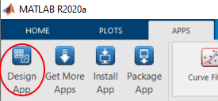
When prompted, choose 2-Panel App with Auto-Reflow.

Design View
In the design view, design a GUI like this:
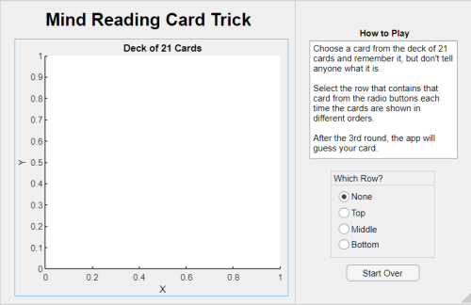
The essential things are as follows. Select each component and the corresponding entry will be highlighted in the Component Browser.
- You have one axis called app.UIAxes. Make sure Position > DataAspectRatio is set to 1,1,1 and PlotBoxAspectRatio is also 1,1,1, because we want to make the cards look right.
- You have one button group called app.WhichRowButtonGroup with 4 radio buttons
- The first radio button, which is pre-selected, is named "None", and the remainder "Top", "Middle", and "Bottom"
- You have one button called app.StartOverButton

Code View
Now it's time to switch to the Code View. It should be prepopulated with auto-generated code. Now it's time to add your own code.
We will repurpose the code we used in the blog post, with some modification, to make it work with the app. We also need to find the right places to add the code. We will be adding callback functions to respective components, and we also need to add additional code that helps the code for the respective components to work together. We will:
- Declare some variables as private properties of the app; in this way, all functions for the app can access these.
- Add some functions as static methods of the app. These are part of the app but don't depend on the app to function.
- Add some functions as private methods of the app, because they are used across several callback functions.
- Add some functions as a callback function to a specific component.
For your convenience, all the code you need is also in a separate txt file: appFunctions.txt

Private Properties and Private Functions
Go to the toolbar, you will see the following buttons.
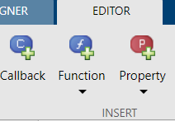
Let's start by selecting Property > Private Property. Here we add two properties.
- placedCards: holds the string array of cards currently placed
- counter: keeps track of the loop.
properties (Access = private)
placedCards % string array of placed cards
counter % double as loop counter
end
Now go back to the menu and select Function > Private Function. This adds the methods (Access = private) section in the code. Leave it blank for now. We will come back to this later.
methods (Access = private)

end

Static Methods
Between the private properties and private methods, declare static methods as below, and add function initialize21Cards. You can call this method later using the syntax, app.initialize21Cards().
methods(Static)
function cards = initialize21Cards()
deck = ["♠","♥","♦","♣"] + ["A"; (2:10)';'J';'Q';'K'];
shuffledDeck = deck(randperm(numel(deck)));
picked = shuffledDeck(1:21);
cards = picked(randperm(21));
end
end

Startup Function
Now let's add the StartupFcn callback to initialize the app, by right-clicking the UIFigure component in the Component Browser, and selecting Callbacks > Add StartupFcn callback.
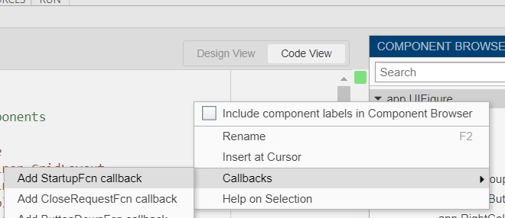
This adds the startupFcn section in the code, where you write the code to initialize the app.
function startupFcn(app)
cards = app.initialize21Cards();
cards = cards(randperm(21));
placed = reshape(cards,[3 7]);
app.counter = 0;
app.placedCards = placed;
plotCardsFaceUp(app,placed)
end
- Call the method initialize21Cards, defined earlier, to set up the deck of cards
- Shuffle the deck
- Place the cards into a 3x7 layout
- initialize counter property to 0
- initialize the placedCards property to the current card layout
- Then plot the cards face up. We haven't defined this function yet.

Start Over Button Function
This button resets the app to the initial state, and therefore uses pretty much the same thing as the Startup function. We just need to clear the axis beforehand. You can add this function by right-clicking the app.StartOverButton component in the Component Browser, and selecting Callbacks > Add ButtonPushedFcn callback.
function StartOverButtonPushed(app, event)
app.UIAxes.cla;
cards = app.initialize21Cards();
cards = cards(randperm(21));
placed = reshape(cards,[3 7]);
app.counter = 0;
app.placedCards = placed;
plotCardsFaceUp(app,placed)
end

Radio Button Group Function
The user selects a button based on which column contains the chosen card and that changes the layout of the cards. This provides the core functionality of this app. You can add this function by right-clicking the app.WhichColumnButtonGroup component in the Component Browser, and selecting Callbacks > Add SelectionChangedFcn callback.
function WhichRowButtonGroupSelectionChanged(app, event)
selectedButton = app.WhichRowButtonGroup.SelectedObject;

% use the code from the text tile
end
- It first detects which button is selected. If it is "None", then the function does nothing
- The "None" radio button is re-selected
- Call restack to collect the cards into a stack and place them again; the details are in the subfunction restack
- If the counter is less than 4, then the card placement is saved to the property, the counter is incremented, and the axis is cleared, and the new layout is shown
- If the counter is 4, then the answer is picked, the axis is cleared, the answer is shown

Back to the Private Function
We haven't added the plotCardsFaceUp function yet. We are now ready to add it to the Private Function.
First, let's add the plotCardsFaceUp function. This calculates the position of each card and then plots them. Then we add plotCardsPiled, which adds an animated effect of the cards gathered into 3 piles. Then we add plotCardsStacked, which also adds an animated effect of piles added to a stack.
methods (Access = private)
function plotCardsFaceUp(app,cards)
[recPos,txtPos,seq,axisLim] = positionCards(app,cards);
plotCards(app,recPos,txtPos,seq,axisLim,true)
end

function plotCardsPiled(app,cards)
[recPos,txtPos,seq,axisLim] = positionCards(app,cards);
recPos = recPos([1,8,15],:);
txtPos = txtPos([1,8,15],:);
seq = seq([7,14,21]);
plotCards(app,recPos,txtPos,seq,axisLim,true)
end

function plotCardsStacked(app,cards)
[recPos,txtPos,seq,axisLim] = positionCards(app,cards);
recPos = recPos(8,:);
txtPos = txtPos(8,:);
seq = seq(14);
plotCards(app,recPos,txtPos,seq,axisLim,true)
end
end
All three functions require two subfunctions: positionCards and plotCards. The first one calculates the positions of the cards and the second one plots them. Add them below the plotCardsStacked function.
function [recPos,txtPos,seq,axisLim] = positionCards(~,cards)
% use the code from the text tile
end

function plotCards(app,recPos,txtPos,seq,axisLim,addLabels)
% use the code from the text tile
end

Run Your App and Play
Now the app is ready. Just hit the Run button in the menu and your app will come to life.
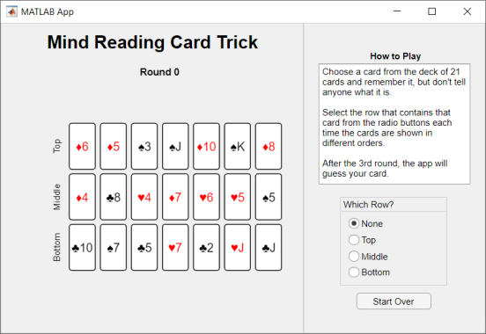
Now you can customize this app to your heart's content. Enjoy!
© 2020 The MathWorks, Inc.

